Reality by Design

SVS ™
Desktop Version
User’s Guide

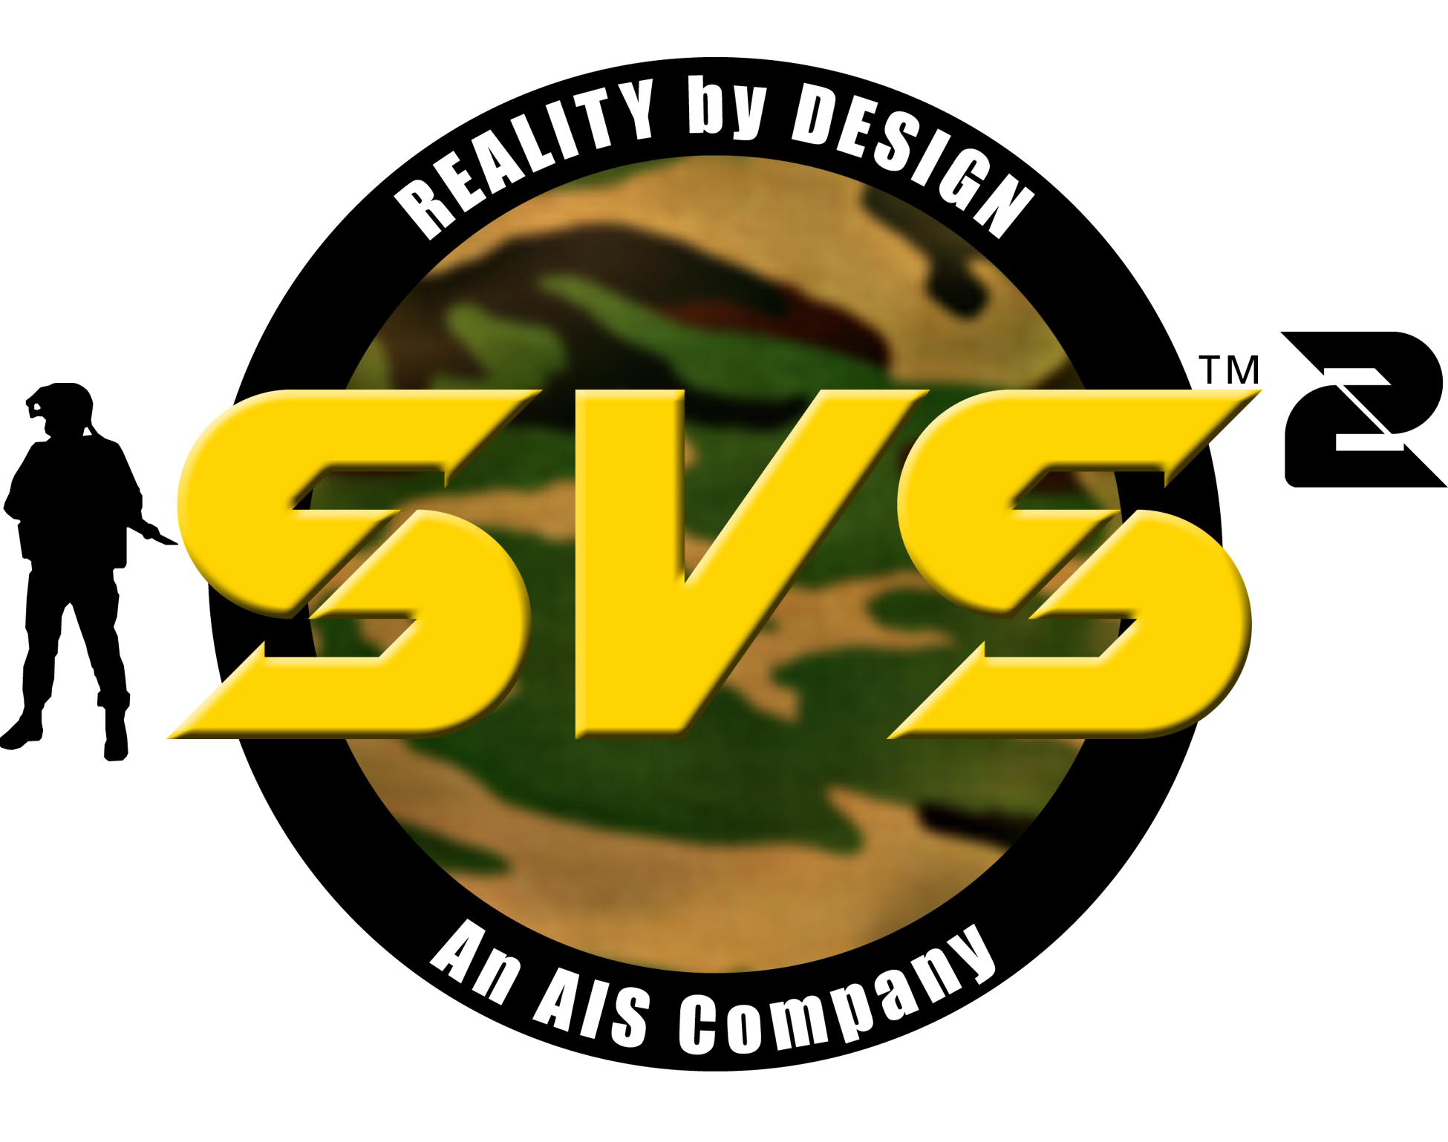

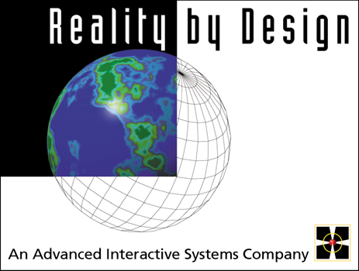
Reality by Design, Inc.
12001 Science Drive
Orlando, Fl 32826

Tel: (407) 736-0066
www.rbd.com

Disclaimer
RBD™ assumes no liability for damages or injuries (consequential or otherwise) caused by the improper use and/or improper installation of this product, or where this product is used in any application other than what it was designed for and intended. RBD expressly denies any responsibility if this product has been modified without RBD’s™ prior written approval, or if this product has been subjected to unusual physical or electrical stress, or if the original identification marks have been removed or altered.

Copyright
COPYRIGHT © 2002. All rights are reserved. This manual and the software described in it are copyrighted and all rights are reserved. No part of the contents of this document may be reproduced or transmitted in any form or by any means, electronic or mechanical, for any purpose, without the express written permission of RBD.
The Software is owned by Reality by Design, Inc. and is protected by United States copyright laws, international treaty provisions, and all other applicable national laws. The user must treat the Software like any other copyrighted material except that the user may make one copy of the Software solely for backup or archival purposes.

The user may not modify, reverse engineer, decompile, disassemble, or create derivative works based upon the Software. The user may not rent or lease the Software, but may transfer the Software, any accompanying hardware, and user documentation, on a permanent basis provided that no copies are retained.

U.S. Government Restricted Rights
The software and documentation are provided with RESTRICTED RIGHTS. Use, duplication, or disclosure by the Government is subject to restrictions as set forth in subparagraph (c)(1)(ii) of the Rights in Technical Data and Computer Software clause at DFARS 252.227-7013 or Rights in Technical Data - General, including Alternate III at 48 C.F.R 52.227-14, as applicable.

Limited Warranty
Reality by Design, Inc. warrants that the Software will perform substantially in accordance with the accompanying written materials for a period of thirty (30) days from the date of receipt; and that any hardware accompanying the Software will be free from defects in materials and workmanship under normal use and service for a period of one (1) year from the date of receipt. Software maintenance is offered at no extra charge for the Limited Warranty Period. Reality by Design, Inc. is not responsible for operating system software, hardware maintenance, or on-site support.

There are no other warranties, expressed or implied, by operation of law or otherwise, of any item or service furnished. Reality by Design, Inc. and its suppliers disclaim all other warranties, either express or implied, including, but not limited to implied warranties of merchantability and fitness for a particular purpose, with regard to the software, the accompanying written materials, and any accompanying hardware.
In no event shall Reality by Design, Inc. or its suppliers be liable for any damages whatsoever (including without limitation, direct or indirect damages for personal injury, loss of business profits, business interruption, loss of business information, or any other pecuniary loss) arising out of the use of or inability to use this product, even if Reality by Design, Inc. or its suppliers have been advised of this possibility of such damages. In any case, Reality by Design, Inc.'s and its suppliers' entire liability under any provision of this agreement shall be limited to the amount actually paid for the software and/or hardware.

Technical Support
Reality by Design
800-260-4044
Monday – Friday
8:00AM – 4:00PM Pacific Time

Table of Contents
Table of Contents 3
Introduction 1
Land Warrior Support 1
Industry Standard Model and Database Format 1
Software Operation – SVS DI 2
RBD Launch Dialog Menus 3
Joystick Functionality 5
Simulation Control Window 7
Environment Settings 8
Teleport Locations 9
File Menu 11
Reload Terrain 11
Options Menu 13
Show/Hide Options 13
View Menu 14
Human Menu 15
SVS Menu 15
New Profile 16
Operational Considerations 21
Externally-Sourced Activity 21
Close Range Firing 21
Third Person View 21
Object Demolition 21
Joystick Response 22
Apparent Lack of Response 22
Starting and Teleport Location 22
Entity Type 23
Entity Marking 23
Audio 23
Speakers/Sound 23
Fatalities 24
View Plane Limits 24
Combatant Animation 24
Terrain Display Problems 24
RBD Object Manager 25
DIGuy Character 30
RBD Database Manager 32
SVS Chem/bio 34
SVS Stealth 35
Creating a Stealth Profile 35
Profile Options 38
Stealth Option 38
Runtime Option 39
Logger Option 39
Database Option 40
Visual Option 40
DIS Option 41
Stealth Menus 42
Attach Menu 42
Stealth Menu 42
View Menu 42
SVS Authoring 44
Computer Generated Forces(CGF) 44
Scenario Development Tool 48
Troubleshooting 57
General Visualization 57
Abnormal Or No Display 60
Sound 60
Weapon / Firing 61
Movement / Joystick Response 62
Third Person View 63
Entity Marking 64
Obtaining Assistance 65
Phone Support 65
Returning Products 66
In-Warranty Returns 66
Non-Warranty Returns 66
All Equipment Returns 66
Appendix A Error! Bookmark not defined.
InterSense Mark 2 Box Configuration for CAM Error! Bookmark not defined.
Appendix B Error! Bookmark not defined.
InterSense Mark 2 Box Configuration for M4 Weapon Error! Bookmark not defined.
Appendix C 68
Computer Basics 68
Computer Terms 68
Windows® Conventions 68
Turning the Computer Off 70
Method 1: Normal Shutdown 70
Method 2: Program Not Responding Shutdown 70
Method 3: Abnormal Shutdown 71
Method 4: Emergency Shutdown 71
Glossary 72

Introduction

Reality by Design’s™ SVS™ Simulation System offers advanced solutions for today's demanding Individual Combatant, Chem/Bio, and Stealth Simulation requirements. It provides a realistic and effective integration of an individual participant into a networked simulation.

The desktop version of the SVS System provides an individual combatant, chem./bio, and stealth virtual simulation system featuring real-time 3D graphics, directional audio, and an intuitive user interface into the virtual battlefield. SVS realistically inserts a man-in-the-loop into the Distributed Interactive Simulation (DIS) or High Level Architecture (HLA)-networked simulation.

The SVS Desktop Simulation is most effective when networked with other simulation workstations. This supports realistic interaction between others active on the simulation network. The SVS Desktop Simulation can interact with other DIS-compatible simulators on the same DIS network. The SVS Desktop Simulation is also compatible with the HLA, which is designated as the standard architecture for all new Department of Defense (DoD) simulations. RBD supports multiple HLA Federate Object Models (FOMs).

Land Warrior Support

The Land Warrior (LW) program is part of the U.S. Army’s modernization plan known as Force XXI. SVS Desktop Simulators optionally configured for Land Warrior support include features such as lasing targets and sending the LASE information back to the LW computer. SVS Land Warrior Immersive simulators provide a separate line of sight into the virtual environment for weapon or sensor views.

Industry Standard Model and Database Format

SVS Desktop Simulation fully supports MultiGen’s industry standard OpenFlight file format, which is used by the majority of DoD. This means that OpenFlight database files being used with other simulations (even on different types of computer equipment) are compatible with the SVS Desktop Simulation. SVS Desktop Simulators can utilize the many existing OpenFlight models and databases currently available without the need to purchase additional translation software. SVS also supports the use of SEDRIS format databases.

Software Operation – SVS DI

Once a simulation is started, you become the combatant (this initial description is for running DI, but functions are similar for chem./bio. Stealth operation described separately), and are equipped with the weapon(s) and ammunition supply specified in the Profile. Use the Joystick to control most aspects of the simulation, including movement, viewpoint, and weapon action. The rate of movement is realistically limited to that attainable by a typical human. Viewing angle and stance can be varied using Joystick controls.

If you are correctly configured and connected to an appropriate network, you may encounter friendly or enemy forces with which you can interact. These may come from another simulation station, or may be computer-generated.

When you incur a hit from incoming fire, you become a fatality. Depending on the Profile configuration, you may automatically reincarnate, or (if permitted) you can access the SVS Simulation Control Window and manually reincarnate. To access the Simulation Control Window:
- Hold down the ALT key while pressing the TAB key once, then release them, or:

- Use the Mouse to reveal the Windows Taskbar (normally located at the bottom of the Display), then click the [RBD] SVS item on the Taskbar.

Either of these two operations will bring the SVS Simulation Control Window to the foreground.

To start a simulation:
To start a simulation, click on the SimStorm icon on the desktop.  The RBD Launch dialog will display. | 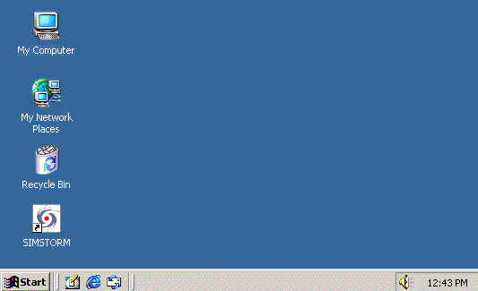

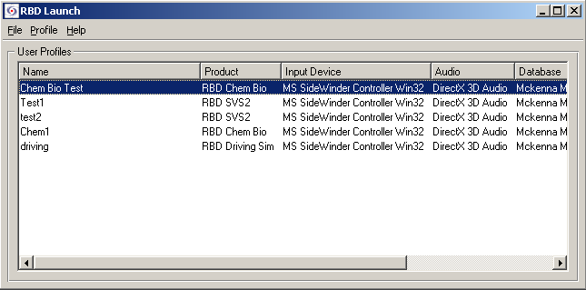

Double click on the Profile you want to run, or select the Profile then choose Run Profile from the File menu to start the simulation.

NOTE: It is important that the correct Profile is selected in order for the simulation to perform predictably, and to establish interaction with other simulation stations that are currently on-line.

RBD Launch Dialog Menus

File Menu
Run Profile – starts the simulation based on the selected profile.
Options – displays the RBD Options dialog. These settings are independent of the Profile.
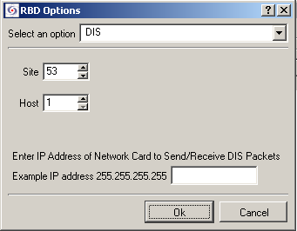

When the DIS option is selected, the following network related parameters can be set:
- Site – location of the simulation workstation. The Site setting is used to identify the facility where the workstation is physically located. This value is normally assigned by the network administrator.
- Host – specific workstation. The Host setting is used to uniquely identify each simulation workstation at a site. If two workstations at the same site are set to the same value, operation of the workstations will conflict.
Enter the IP address then click OK.
Exit – exits the SVS application.

Profile Menu
New Profile – used to create a new profile.
Profile Options – displays the profile options for the selected profile.
Delete Profile – deletes the selected Profile.

Joystick Functionality

Use the Joystick to execute the simulation. The tables below summarizes the functions controlled by the Joystick.
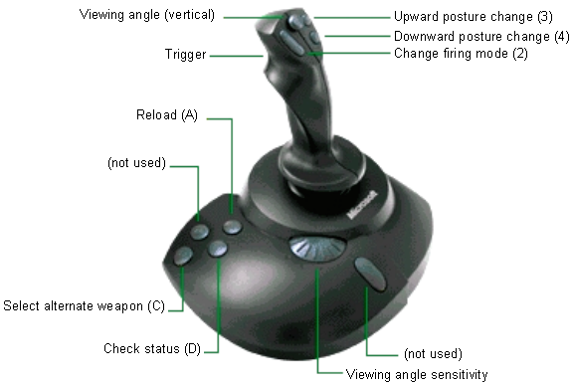
NOTE: The light gray semi-circle on the left of the Joystick base adjusts the rate that the Viewing Angle Control (Hat) varies the view angle. Forward (clockwise) is faster.

Pressing the D button on the base of the joystick displays the currently selected weapon, number of rounds, etc., in the lower right corner of the simulation window.

COMBATANT MOVEMENT

Function | Joystick Operation
Forward Movement | Push Joystick Forward
Backward Movement | Pull Joystick Back
Right Movement (side-step right) | Push Joystick Right
Left Movement (side-step left) | Push Joystick Left
Right Pivot in Place (turn to the right) | Rotate Joystick Clockwise
Left Pivot in Place (turn to the left) | Rotate Joystick Counter-Clockwise

COMBATANT VIEW AND POSTURE

Function | Joystick Operation
Look Up | Pull Hat Back
Look Down | Push Hat Forward
Restore Straight View | Push Hat Left or Right
Downward Posture Change (to kneel, to prone) | Press Button 4
Upward Posture Change (from prone, from kneel) | Press Button 3

WEAPON FUNCTIONS

Function | Joystick Operation
Fire Weapon | Pull Trigger on Joystick
Change Firing Mode (Safe, Semi-auto, Auto) | Press Button 2
Reload Weapon | Press Button A (on Base)
Select Alternate Weapon | Press Button C (on Base)  after pressing button D
Check Status | Press Button D (on Base)

NOTE: Some of the functions listed may not be allowed in the Profile configuration. For example, the RELOAD button on the Joystick will not function when the pre-determined ammunition supply is exhausted.

Simulation Control Window

When the SVS simulation is running, a second Control Window is running in the background. The Control Window provides control for some of the parameters that affect the local simulation. To access this window:
- while holding down the ALT key, press the TAB key then release.
- with the mouse, click the RBD SVS item on the taskbar on the bottom of the screen.

NOTE: If the 3D Simulation window has been minimized, the Control window will not function.

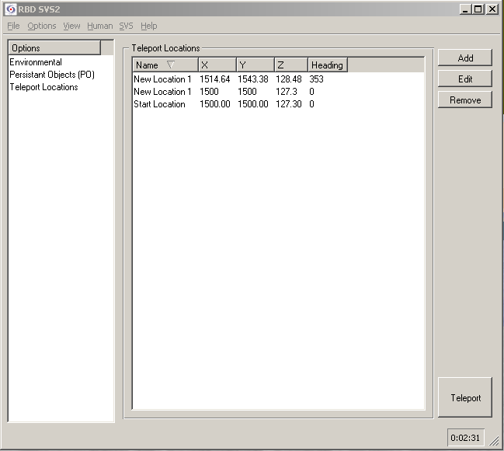

Environment Settings

The Environmental Settings dialog is where the weather conditions and lighting/visibility are set.

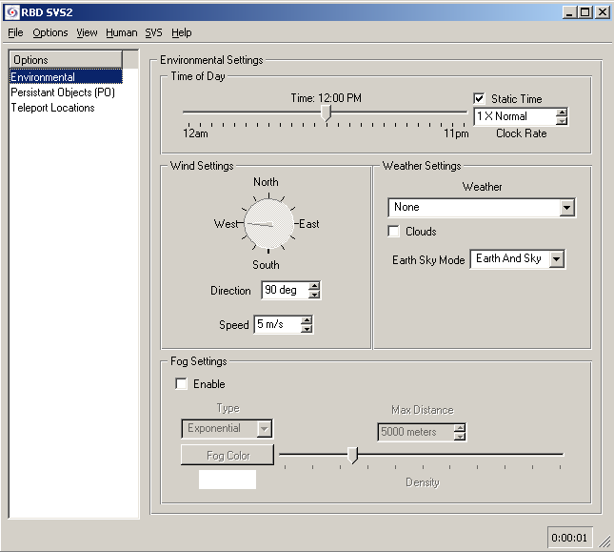

Time of Day – Lighting conditions can be changed by moving the slide bar to a different time of day. If Static Time is checked, the time nor the light will change after it is set. If unchecked, the time will change according to the Clock Rate setting.

Wind Settings – set the speed and direction of the wind. The direction can be changed by changing the number in the Direction box or by clicking and dragging the pointer in the circle.

Weather Settings – select None, Rain, or Snow in the drop down list. Check the Clouds checkbox to display clouds in the sky.

Fog Settings – Check the Enable check box to put fog in the simulation. In the Type drop down list, Linear puts fog on the horizon and Exponential and Exponential 2 put fog in the foreground.
Clicking the Fog Color button displays the standard color selection dialog. Select a color then click OK.
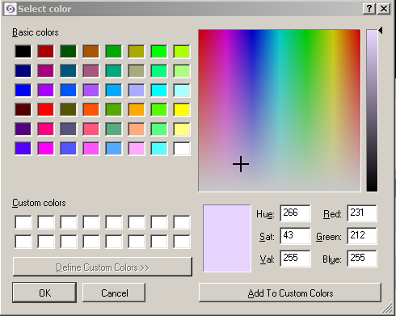
Set the density of the fog with the Density slide bar.

To save the settings, select Save Environmental Settings or Save Environmental Settings As from the File menu.

Teleport Locations
Teleport instantly relocates the point of view to a specified location and heading. In the Teleport Locations list, a startup location is listed, along with any additional locations that have been added to the list.

To change locations, double click on the desired location or, select a new location from the list and click the Teleport button.

To add a new location to the list, Click the Add button. The Teleport Data dialog box displays with the coordinates and heading of current location.

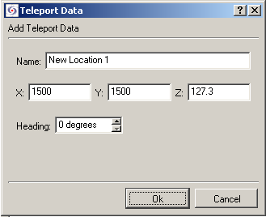

Enter a name for the new teleport location. Enter the X, Y, and Z coordinates.
X represents a relative east-west position in meters.
Y represents a relative north-south position in meters.
Z represents elevation in meters.
Heading is the viewing and firing angle in degrees relative to north.

Click the OK button when finished.

File Menu

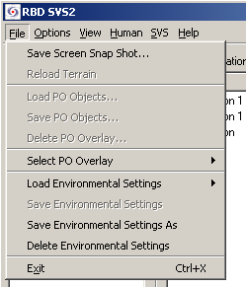

Save Screen Snap Shot...
The Save Screen Snapshot menu option will capture the image currently displayed in the 3D Simulation Window and save it in an .rgba-formatted graphics file. This file can be viewed and printed via a compatible graphics program (not supplied by RBD). Make note of the Windows Folder name where the file is stored. The default Folder is C:\RBD\USER\SNAPSHOTS.

NOTE: Viewing programs for rgba-format images may be available on the Internet at:

http://www.apple.com/quicktime/download/support/ or
http://www.acdsystems.com/english/products/download.htm

(RBD offers this information as a courtesy, but does not offer technical support for these programs. Check with the program’s supplier for licensing requirements. These programs are not covered by RBD’s software licensing agreement).

Alternatively, to save the screen as a Windows Bitmap file, simultaneously press the ALT + PRINT SCREEN keyboard keys to capture the window to the Windows Clipboard, and then use the Paste function in the Windows Paint accessory program to view, print, or save the image displayed.

Reload Terrain
The Reload Terrain menu option causes the system to reload the terrain file specified in the current profile. This can be used to restore the terrain to its original state if, for instance, holes have been created in buildings as a result of weapons firing.

Load Environmental Settings
This menu option displays a second menu with all the Environmental Settings that have been save, as show below:

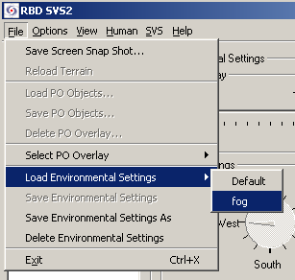

Save Environmental Settings
This menu options saves the currently selected Environmental Settings.

Save Environmental Settings As
Selecting this menu option displays a dialog for naming the settings before being saved:
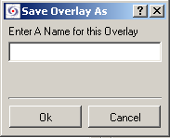

Give the settings a unique name and click the OK button.

Delete Environmental Settings
Selecting this menu option displays a list of all the saved Environmental Settings.
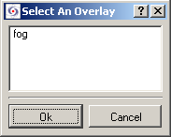

Select the setting you want to delete and click the OK button.

NOTE: Do not use the X button in the corner of the 3D Simulation Window to exit the program. Doing so prevents normal program shut down.

Options Menu
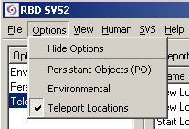

Show/Hide Options
This menu option determines whether the Options listed on the left side of the Control Window are displayed or not.

Persistent Objects (PO)

Environmental
This menu option displays the Environmental Settings dialog where lighting conditions can be set by the time of day as well as set to change with the time of day. Wind, weather, and fog can be also be selected.

Teleport Locations
This menu option displays the teleport settings.

View Menu
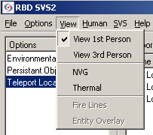

View 1st Person
With this menu option selected, the simulation is shown as if viewed directly by the participant. This is the default view.

View 3rd Person
With this menu option selected, the simulation is shown from a viewpoint one meter behind the participant.

NVG
With this menu option selected, the simulation appears as it would viewed through Night Vision goggles.

Thermal
With this menu option selected, the simulation appears as it would viewed through heat sensing vision goggles.

Fire Lines
This menu option enables or disables display of firing lines from the weapon to the point of impact.

Entity Overlay
This menu options enables or disables local display of pre-defined Entity Identification labels.

Human Menu
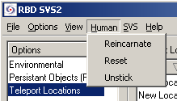

Reincarnate
This menu option allows you to restore the participant and his resources to the initial state. Other participants in the simulation are not affected but continues just as before. When Reincarnate is selected, the participant is reinserted into the simulation at the last position and posture, with ammunition supply restored.

Reset
This menu option will restart the local simulation and renew all settings to their original state or value. This does not affect the simulation for other participants at other workstations.

Unstick
This menu option will release the participant from an inability to move when caused by a terrain database error.

SVS Menu

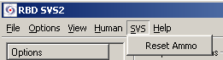

Reset Ammo
This menu option resets the ammo.

New Profile

A Profile is a set of conditions that are specified to determine how a simulation will be conducted.

To create a new profile:
- From the Profile menu, select New Profile. The RBD Products dialog will display.

- Select RBD SVS then click the Next button. | 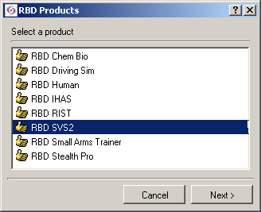
- Select RBD SVS Desktop then click the Next button. | 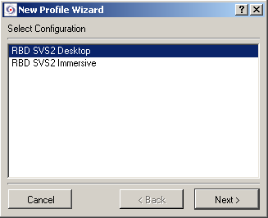
- This Wizard lists devices used to control the simulation. Select the correct device for your system then click the Next button. | 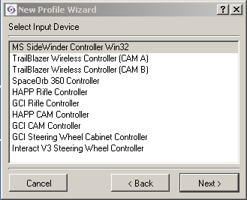
- This dialog lists compatible sound sub-systems. Direct X is the normal setting for the SVS Desktop systems. Click the Next button.  Note: If No Audio is selected, sound can never be used with the profile being created. It is recommended that audio be selected here then disabled using the Windows Sound Control, via the speaker icon on the Windows Taskbar, if no sound is wanted. | 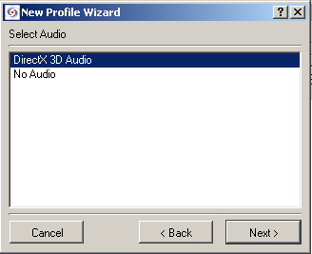
- Select a database appropriate for dismounted infantry maneuvers then click the Next button. | 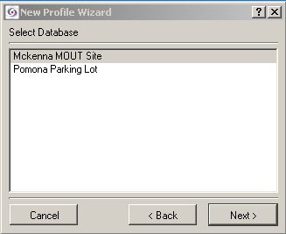
- Select DIS then click the Next button.  NOTE: Selecting No Networking will prevent the profile being created from network interaction. The system will operate off-network even if a network setting is selected in this dialog so it is recommended that a network selection be made. | 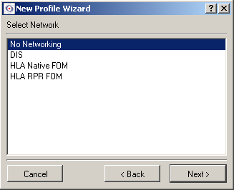
- Enter a unique name for the new Profile. Up to 35 characters and spaces can be used.  - Click the Finish button.  The RBD Launch dialog will display and the new profile will be listed. | 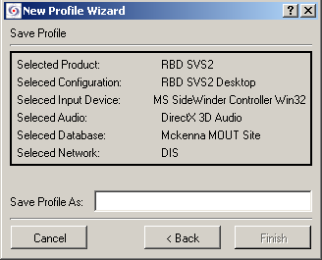

To complete the profile settings, select Profile Options from the Profile menu in the RBD Launch dialog. The Profile Option dialog will display.

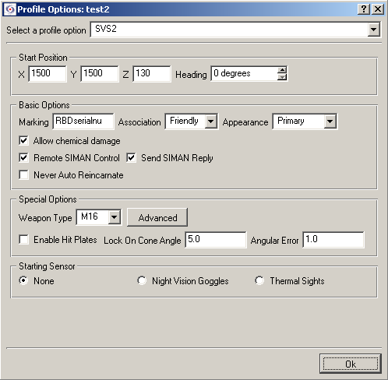

Start Position – this parameter sets the location where the simulation will start.
- X is the east-west number, in meters, relative to the southwest corner of the terrain database.
- Y is the north-south location, in meters, relative to the southwest corner of the terrain database.
- Z is the elevation in meters. If not specified, the ground level for the X-Y location will be used.
- Heading is a degree oriented view setting where 0 is north, 90 is west, 180 is south, and 270 is east.

Basic Options – this group of settings specifies how this simulator will appear locally and how its presence will be identified remotely on other simulators.
- Marking – free form text field that will identify this simulator’s local entity. Up to 11 characters and spaces can be used however, only the first three characters will be overlaind on the animated human icon. The full marking string is shown below the entity (if Entity Overlay is enabled), along with the network address of the simulator.
- Association – allows identification of your local entity as Friendly, Enemy, or Unknown when it is viewed by other workstations in the simulation.
- Appearance-Allows to select the appearance of the character
- Allow Chemical Damage – if checked, entity will be affected by chemical agents that are present.
- Remote SIMAN Control
- Send SIMAN Reply
- Never Auto Reincarnate – if this item is checked, the participant will not automatically reincarnate from a fatality.

Special Options
- Weapon Type – select a weapon from the drop down list. Click the Advanced button to display a weapons dialog box that will allow the number of clips and rounds to be selected for each weapon type.

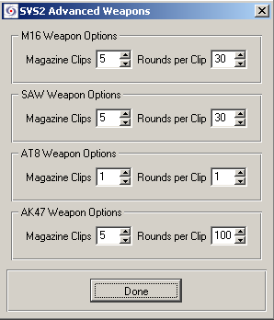
- Enable Hit Plates – not used with desktop configuration
- Lock On Cone Angle – not used with desktop configuration
- Angular Error– not used with desktop configuration

Starting Sensor – determines how the initial 3D Simulation Window is displayed.
- None – normal view
- Night Vision Goggles – simulated view as if through Night Vision goggles
- Thermal Sights – simulated view as if through a thermal (infra-red sensing) sight.

Operational Considerations

The following information explains special situations that should be taken into consideration during the simulation:

Externally-Sourced Activity
If you are on a network and the networking parameters in Profile Options are set appropriately, you may see activity from other workstations located either at your facility, or virtually anywhere in the world where access to the simulation network is available.

You may incur incoming fire from any other Entity in the simulation, including computer-generated forces. Settings and activity at your workstation have no direct affect on Entities other than hitting them with appropriate fire power. Incoming and outgoing fire can exceed the field of view limits.

Close Range Firing
If you fire a weapon at an object near to you, you may incur a fatality, in which case a red screen will be displayed.

Third Person View
The Entity Type (e.g. US Dismounted Infantry with M16 weapon) selected in the Profile determines how the person and the weapon are displayed.

In the Third Person view, firing is straight ahead, regardless of the weapon angle displayed.

NOTE: If you change from First Person to a Third Person view while positioned with your back very near some object (e.g. a building), your viewpoint will be “transported” back into that building, thereby obstructing your view.

Your position (i.e. standing, kneeling, prone) is readily apparent in Third Person view, where it may not be obvious in the First Person view. If you are kneeling in Third Person view and initiate a move, the animated figure will assume an upright position until the move is completed, and then automatically return to the kneeling position.

Object Demolition
Objects in the current Terrain Database must be configured to allow demolition; otherwise, firing a weapon at that object will have no affect. It is common for only some objects to be configured to allow demolition. It is also common for the results (e.g. a hole) to take several seconds to appear on that object. Some weapons (e.g. M16) cannot demolish any object, even a door or window; and therefore cannot fire through a window opening if it contains a glass pane (as indicated by a window frame structure).

Normally, after firing results in a displayed demolition, it is possible to proceed through that opening if it is at an appropriate level. It is not possible to “climb” or jump up through a high level opening.

Joystick Response
The rate of movement and mobility are limited to realistic human capabilities. At times you may not be able to move because you are up against something that is below your viewport. Use the Hat control to look downward for a low object that may be blocking movement.

The sensitivity of the Hat (i.e. vertical view angle) control is set by a rotary control on the base of the Joystick.

If you are in a kneeling or prone position and attempt to move, movement will be slower than when standing. Movement speed is intentionally related to posture, as in real life. Use the Joystick to stand up in order to remedy the slower movement.

Apparent Lack of Response
If movement is hampered, select Unstick from the Human menu in the Control Window. The Terrain Databases may contain some inconsistencies that prevent normal movement at certain points. Try turning the Joystick to face in another direction – the UNSTICK function will only work if there is a location available to move to that is one meter in front of your present position.

Some controls, for example Reload, may be limited by settings in the Profile. If the allotted ammunition supply is exhausted, the RELOAD button on the Joystick will not function.

If the weapon-firing mode is set to “Safe”, the trigger will not respond.

Some objects on the simulation screen may not be set to allow them to incur damage from being hit. Those that do show a response to fire may take several moments to do so.

Some weapons will have no effect on certain objects. For example, an M16 will have no effect when firing at a tank, or the wall of a building.

Starting and Teleport Location
The starting and Teleport location must be within the confines of the currently loaded Terrain Database, or the scene may display incorrectly.

Entity Type
The Entity Type (e.g. US Dismounted Infantry with M16 weapon) specified by the currently selected Profile determines certain capabilities, limitations, and the appearance of the participant and their weapon when viewed in Third Person mode.

Entity Marking
The Entity Marking content is determined by settings on the workstation controlling that entity. Only the first three characters of the Entity Name can be displayed directly on an animated human participant, although the full name and Entity Source Address is displayed near the feet of the animated participant if Entity Overlay is enabled in the current Profile. That marking will be superimposed over objects in the scene when those objects are positioned between your viewpoint and an Entity that is out of your line of sight.

Display (i.e. enable/disable) of Entity Markings is controlled by your local Profile settings.

Audio
If sound is not heard, it may be because of one of the following:
- Sound is not enabled in the Profile
- The Windows sound level is too low, or is set to “mute”
- The speakers are turned down, off, or are disconnected

Speakers/Sound

SVS can provide sound feedback when weapons are fired. The sound capability can be disabled during Profile creation, but we recommend enabling during Profile creation and controlling the level setting via the Windows Volume Control.

Many speakers have volume controls built in. It is recommended setting that control to maximum and then using the Windows Volume Control for adjustments.

NOTE: Some speakers also have an external power supply. Ensure that it is connected properly and plugged into a live AC power outlet.

Ensure that the speakers are connected to the “Out” or “Speaker” connector on the computer. Do not use “Line Out”, ”Mic”, or “Input”.
Headphones may be used as an alternative to the speakers. Lower volume settings will normally be required.

Fatalities
All occurrences of a human entity being hit by fire from any source results in a fatality. Additionally, firing your weapon too close to an object will also result in a fatality. Incoming fire can exceed the field of view limits.

When a fatality occurs, the screen goes red momentarily. The Profile can be configured to allow automatic reincarnation, in which case you will be restored to your previous position in about 5 seconds. You can also manually reincarnate from the Human menu in the Control Window.

View Plane Limits
If Entity Overlay is enabled under the View menu, you will see Entity Identifiers even for entities beyond your field of view. Incoming and outgoing fire can exceed the field of view limits.

Combatant Animation
For some versions of the simulation program, visualization and animation of human entities depends on availability of a current license for the animation feature. If human entities cannot be visualized, please contact RBD for assistance.

Terrain Display Problems
If the terrain is not displayed (i.e. blue sky only, etc.), the initial starting location in the Terrain Database may be inappropriate.

If the terrain does not update following your movement of the controls, it may be necessary to reload the Terrain Database.

If the overall view seems abnormal, check that the Thermal or Night View Goggle option is not activated by examining the settings in the View menu of the Control Window.

RBD Object Manager

The RBD Object Manager is where entities, munitions, and humans appearances are defined.

The Add Object Wizard goes through each step necessary to create an entity/structure, munition, or DI Guy lifeform.
To access the Wizard, click the Object Manager icon on the desktop then select a database from the displayed list. | 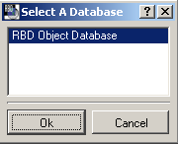

From Object menu in the RBD Object Manager, select Add. | 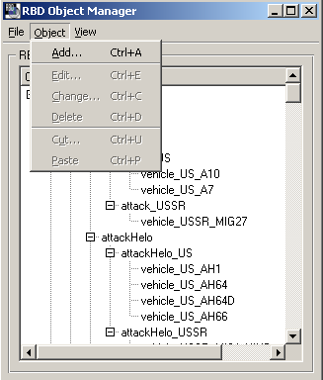

Enter a unique name for the object being created then click the Next button. | 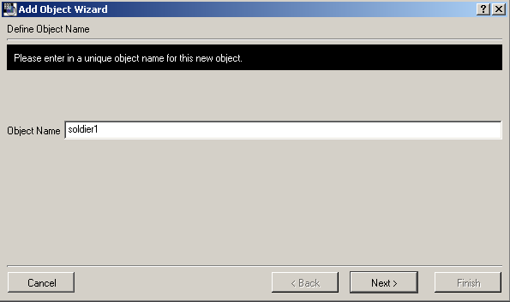

Select the type of entity you want to create. For an Entity/Structure, the following Wizards display. Click the Next button as each Wizard is completed to display the next step. The final one will have a Finish button. | 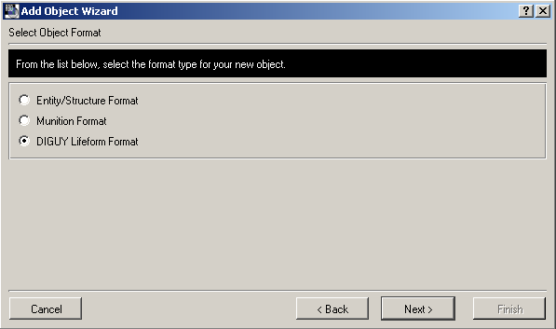

Click the Add button on the Model Wizard. The Object Model Data dialog box will display. | 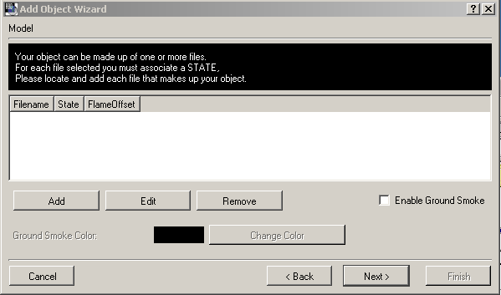

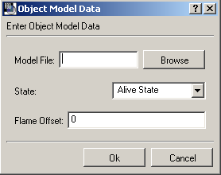

Click the Browse button to display the contents of the Model file. You can select one or more files, but each file must have a State associated with it. Alive State is the default selection.

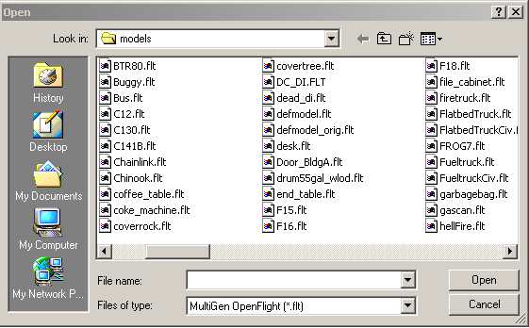

Each entity can have a sound associated with it if desired.
Click the Browse button to display the list of .wav files available. | 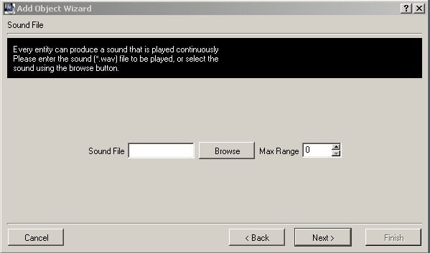

Select the .wav file to be associated with the entity.  If no sound is wanted, click the Next button on the Sound Wizard without making a selection. | 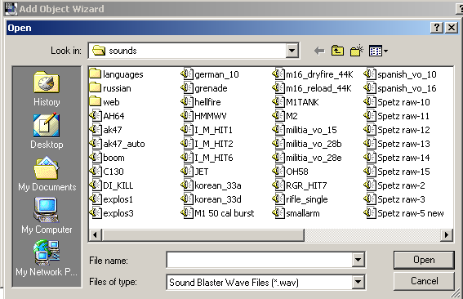

Using the DIS Standard for network information, enter the DIS network enumeration for the entity being created then click the Finish button. | 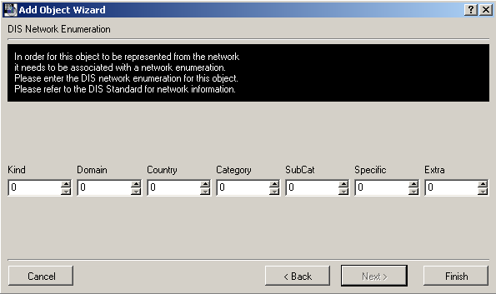

If Munition Format is selected in the Select Object Format, the following Wizards display:

Select the munition dynamics, max speed and hit results then click the Next button. | 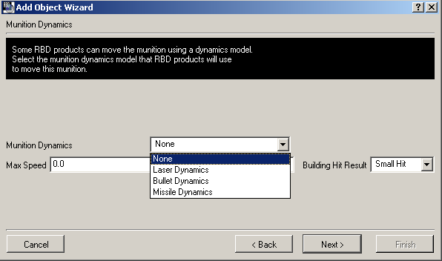

Clicking the Browse button will display the .flt files available in the Models file folder. | 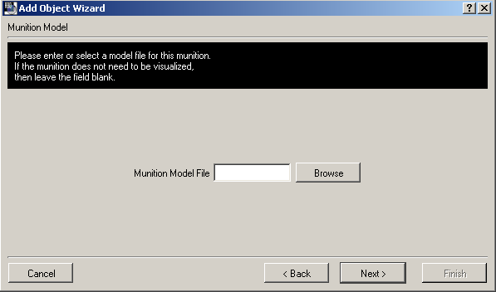

The munition animation and munition sound Wizards display next:

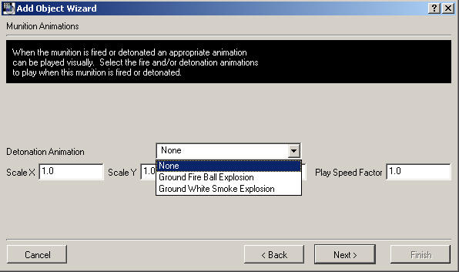 | 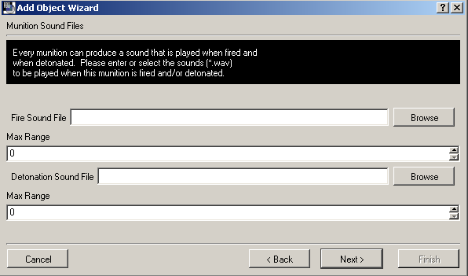

The Munition DIS Network Enumeration is the last Wizard to display:

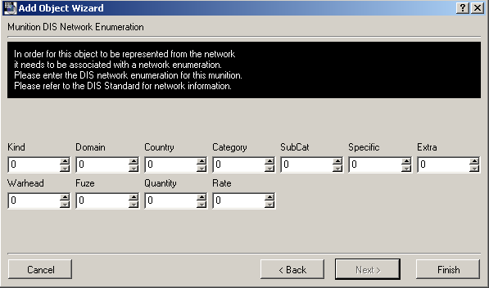

Complete this Wizard then click the Finish button.
If DIGUY Lifeform Format is selected in the Select Object Wizard, the following Wizards display: (NOTE: DIGUY is an optional package)

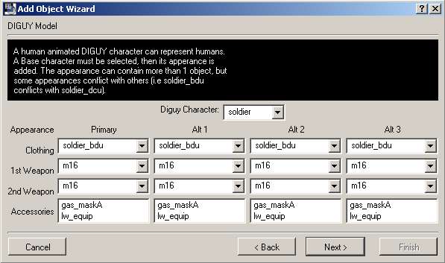

Make selections from the following drop down lists:

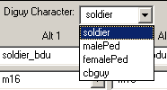  Clothing  DIGuy Character | 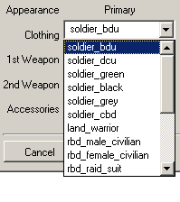
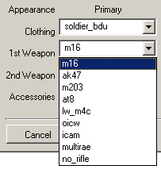  1st Weapon | 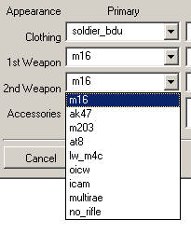  2nd Weapon

Complete the DIS Network Enumeration Wizard then click the Finish button.

RBD Database Manager

Use the RBD Database Manager to create a new database or to edit an existing one.

To create a new database, select Add from the File menu of the Database Manager:
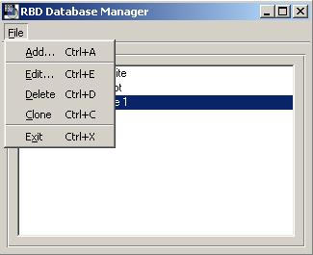

The Add Database Wizard takes you through each step necessary to create a database. Enter the information requested on each Wizard then click the Next button. The final Wizard will have a Finish button.

Clicking the Add button on the search path wizard will display a list of database folders. Select the location of your files then click Next. | 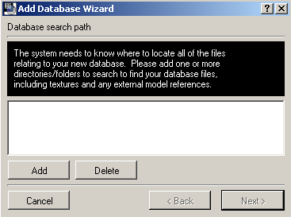

Continue on through each of the following Wizards, clicking the Next button as each one is completed.
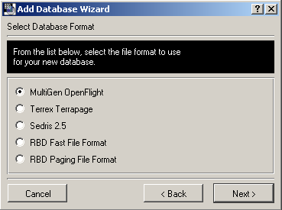 | 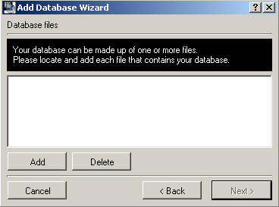

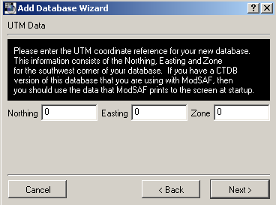 | 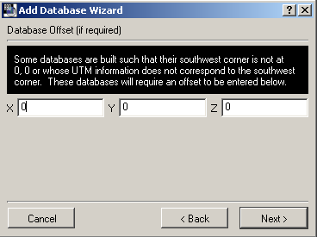
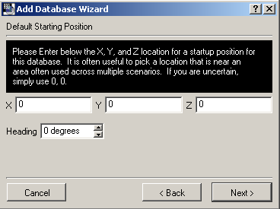 | 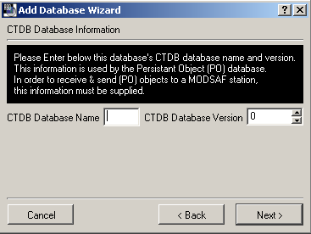

In the final Database Wizard, enter a name for your database then click the Finish button.

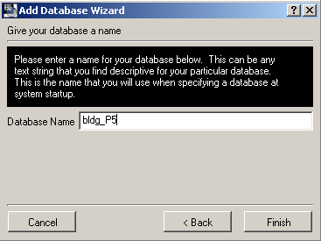

SVS Chem/bio

Most of the setup and operation of SVS Chem/Bio is the same as that

+**** Show joystick functions for chem./bio – this is for desktop *********

On/Off Mode switch controls the different modes:
- The menu of objects
- The switching of devices and functions.
The List of Functions, Objects and Devices:
Multi Rae
Hapsite
CAM
Open and Closing Doors
Picking up objects
Flags (Drop)
ACADAs (Drop)
Wall Markings
Delete Previous Wall Mark
Calibration
Next Sensor
Next sensor feature-(Multi Rae sensors, and CAM G/H) Please see note*

*The Multi Rae has the capability to monitor many different chemical elements.
Switching between these different monitoring sensors enables the user to detect different chemical compounds. In the application this is done through a round robin selection process. Once the user finds the “Next Sensor Feature” queue on the screen the user can switch to the next sensor.
The Multi Rae currently monitors these chemical elements:
02
CO2
CMB Gas
H2S
SO2
NO
NO2
CL
AC
NH3
PH3

The CAM currently monitors two types of Chemical Agents:
G- Blister Agents
H- Nerve Agents

G/H mode switch is the activation of what is selected by the On/Off Mode switch:
- The placing of objects ( Flags and ACADA’s)
- The activation of different functions select by the On/Off Mode switch.

SVS Stealth
RBD SVS Stealth is a tool that gives you an eye point into your virtual battlefields, allowing you to view, debug, and analyze exercises without any interference or effect on the environment, entities, or objects involved in the simulation. You can view simulated battles from any location in the virtual environment.

Creating a Stealth Profile
A Stealth profile must be created before you can move through a simulation.

To create a new Stealth profile, click on the SimStorm icon on the desktop. The RBD Launch dialog displays:

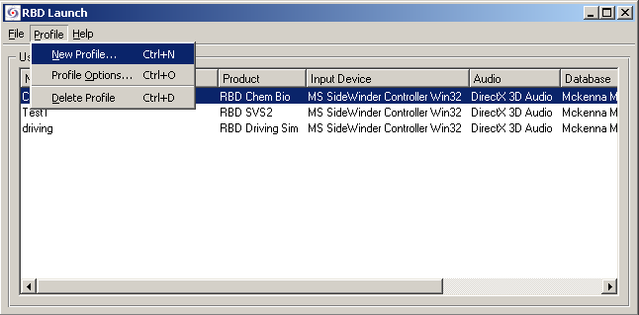

From the Profile menu, select New Profile. The RBD Products dialog displays:

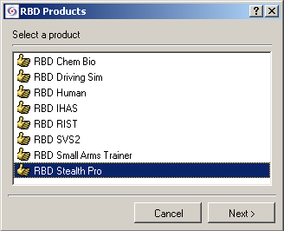 | Select RBD Stealth then click the Next button.

 | Select the brand of joystick being used with the system then click the Next button.
Select the compatible sound system then click the Next button.

NOTE: If No Audio is selected, sound can never be used with the profile being created. It is recommended that audio be selected here then disabled by using the Windows Sound Control, via the speaker icon on the Windows taskbar.
 | Select the desired database then click the Next button.
Select the network then click the Next button.

NOTE: Selecting No Networking will prevent the profile being created from being used with network interaction. The system will operate off-network even if a network setting is selected in this Wizard so it is recommended that a network selection be made.

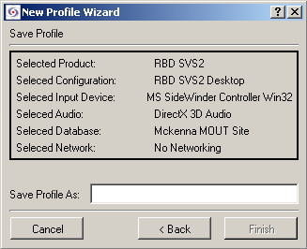 | Enter a unique name for the new profile. Up to 35 characters and spaces can be used.  Click the Finish button.

Profile Options
The following options can be set for each profile: Stealth, Runtime, Logger, Database, Visual, and DIS. From the Select a profile option drop down list, select an option.

Stealth Option
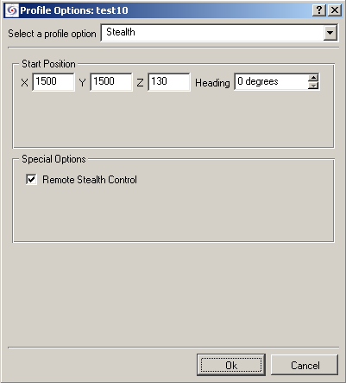

In the Stealth Profile Option dialog, the coordinates and heading of the starting position can be set.

In the Special Options section, the Stealth can be set for remote control.

Runtime Option
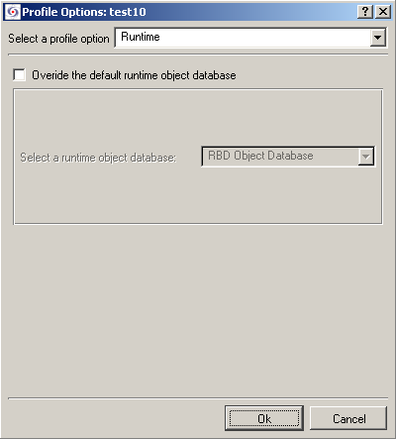

Logger Option
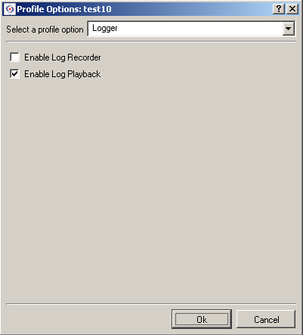

In the Logger Profile Options dialog, recording and playback of a log file can be activated.

Database Option
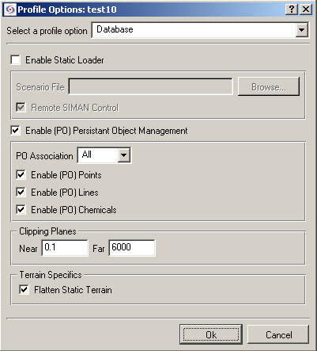

Visual Option
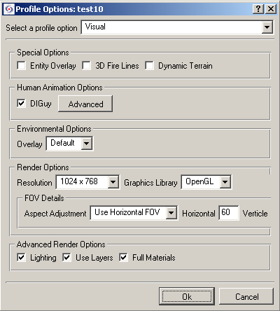

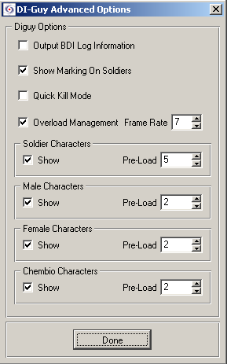

DIS Option
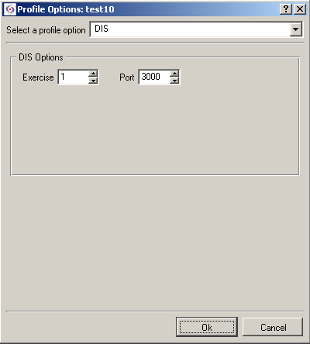

Stealth Menus

Attach Menu

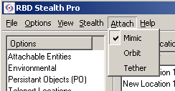

- Mimic – attaches the eye point to mimic what the entity is seeing from a first person point of view.
- Orbit – attaches the eye point a fixed distance from an entity but allows the viewing distance and direction to be controlled using the joystick.
- Tether – attaches the eye point behind the entity. The viewing direction is always the direction the entity is moving.

Stealth Menu

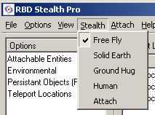

- Free Fly – the stealth can maneuver through walls and objects. Altitude is adjusted using the joystick.
- Solid Earth –
- Ground Hug – follows the terrain. The two buttons on the top of the joystick control the height above or below ground level.
- Human –
- Attach –

View Menu
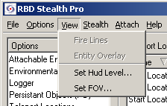

Set HUD Level
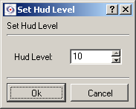

Set FOV
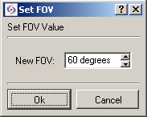

Use the Set FOV dialog to change the field of view.

SVS Authoring

SVS Authoring is an optional SVS product that provides scenario development tools along with the basic SVS Stealth capability. The authoring tools provided include RBD’s own Computer Generated Forces (CGF) and Scenario Development Tool (SDT).
Computer Generated Forces(CGF)
The SVS Authoring Simulation System has a built-in computer generated forces (CGF) capability enabling the creation of complex scenarios involving numerous interactive characters. The CGF entities follow scripted behaviors defined by the author of a scenario. The authoring component of CGF allows the user to define a scenario via either a 2D plan-view map display, a 3D virtual out-the-window display or a combination of both (see Figure 1).
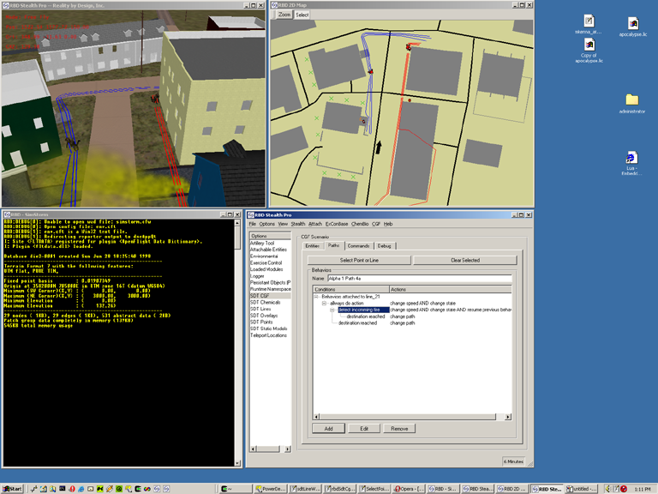
Figure 1 - CGF User Interface with both 3D and 2D displays
The basic operation of the authoring system can be described as a repetitive series of steps as follows:
- Create an “overlay” for the portion of the scenario you want to focus on. You can make a scenario with one or more overlays. Overlays help organize the scenario into manageable sub-projects.
- Create a point, or create a path of 1 to N points by clicking either in the 3D window or on the 2D map (which ever interface you feel most comfortable using). You can give points/paths names to make it easier to remember their purpose.
- Define a series of Condition/Action pairs for defining behaviors along the path or at the chosen point (behaviors are assigned to paths/points – when an entity follows the path, it performs the corresponding behaviors). As shown in Figure 2, path behavior can get quite complex. “Conditions” cause “Actions”. If a selected condition occurs, then the corresponding action (or set of actions) is executed.
- Create an entity and assign it to point/path. The current CGF architecture intends for a single entity to be assigned to a single path.
- Repeat steps 1-4 until the entire scenario is defined.
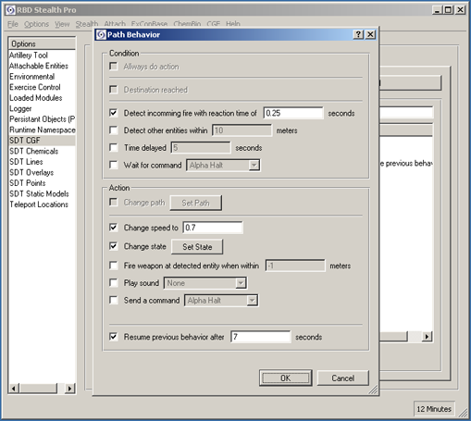
Figure 2 - CGF Condition/Action GUI

As mentioned above, “Conditions” cause “Actions” to be performed in the SVS CGF framework. The Conditions that are available are:
- Always do action. Use this condition to always trigger an action to happen. This Condition must be the only Condition selected when chosen.
- Destination reached. Use this condition to trigger an action when the desired destination (i.e. the end of a path or a selected point) is reached. This Condition must be the only Condition selected when chosen.
- Detect incoming fire. Use this condition to trigger an action when the entity following the path is fired upon. A reaction time is associated with this Condition. The reaction time is the time from when the incoming fire is detected until the beginning of the action. Incoming fire will only be detected from entities that have a different designation than the selected entity (i.e. friendly forces can’t detect incoming fire from friendly forces).
- Detect other entities. Use this condition to react to the proximity of other entities. The detection is within a circle of the supplied radius (in meters).
- Time delayed. Use this condition to cause a time delay before executing some action. The delay time in seconds must be provided.
- Wait for command. Use this condition to cause the entity to wait until a specific command is given before executing actions. As shown in Figure 3, a set of predefined commands are supplied with the CGF tool, and more can be added by the user of the system as desired.
Any of the last four Conditions can be used together to cause an action to occur if any of the conditions are met (i.e. the Conditions are OR’d together). Whereas the first two Conditions in the above list must be used alone (not joined with other conditions).

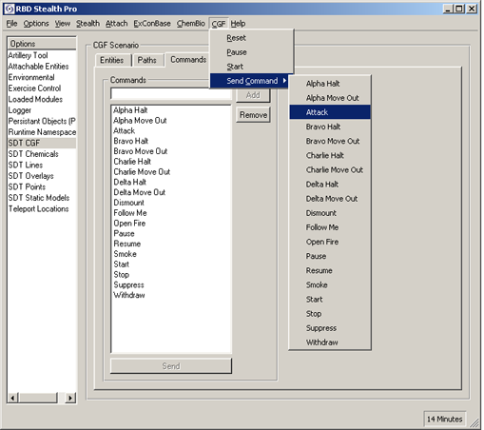
Figure 3 - CGF Predefined Commands
An Action causes the entity to perform a particular behavior. The Actions that are supported by the SVS CGF are:
- Change path. This Action is used to cause an entity to continue to a new path and thus a new Condition/Action pair. The new path must be selected.
- Change speed. This Action is used to cause an entity to change speed. For a human entity, changing the speed will control the animation used for the entity’s movements (i.e. walking, running, standing still). The new speed must be supplied (in meters per second).
- Change state. This Action is used to cause an entity to change state (or appearance). As seen in Figure 4, examples of states include aiming, standing, kneeling, and smoking. Several states can be used together at one time.
- Fire weapon at detected entity within a specified range. This Action is used to cause the entity to fire at any (i.e. any force designation) entity within the range.
- Play sound. This Action is used to cause any predefined sound to be played. Typically, this Action is used to make it appear that the CGF entity is talking/communicating. RBD software uses an “object data base” (ODB) to define entities, munitions and sounds. Any sound defined in the ODB can be selected by the CGF to be played.
- Send a command. This Action causes the entity to send a specified command. For a list of predefined commands, refer to Figure 3. Commands are sent to all other entities within the CGF engine and can be used for synchronization.
- Resume previous behavior. This Action is used in conjunction with one of the other Actions above to cause an entity to return to a previous behavior after a diversion from the base behavior for the specified time period.

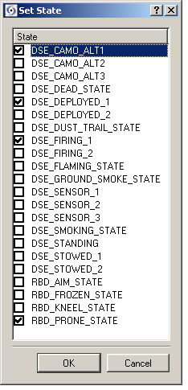
Figure 4 - CGF State List

Scenario Development Tool

The Scenario Development Tool is designed to help the user place objects and entities in the virtual environment; and to create and enhance already existing scenarios.

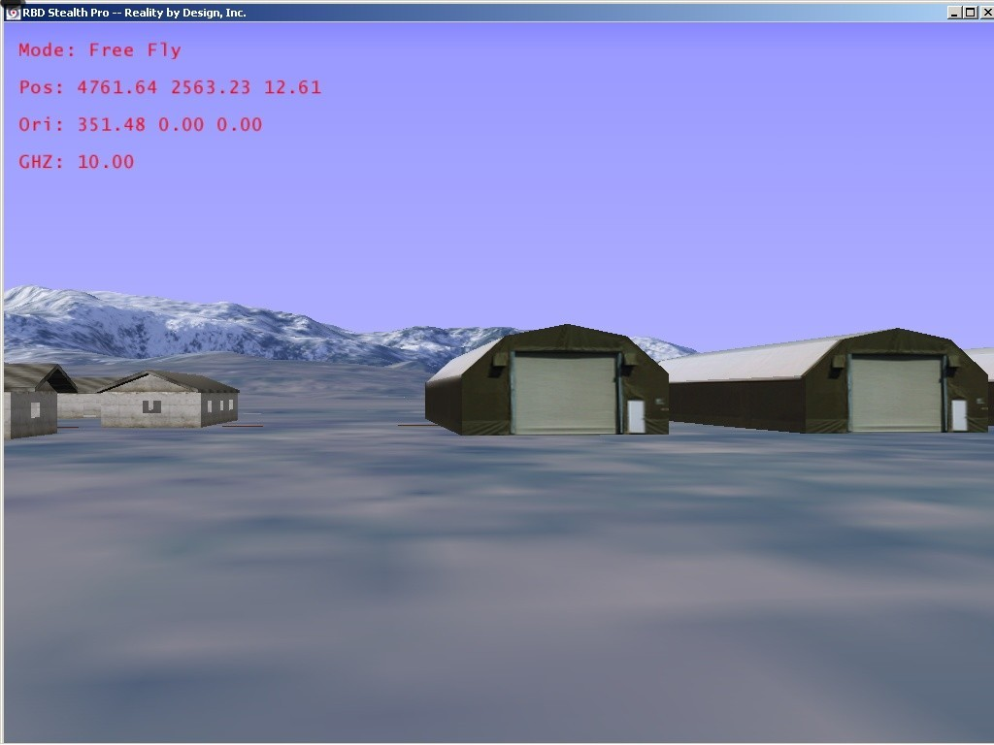

Once in the SVS Stealth and selected database, the user can select from the drop down menu to select different objects and models to place.

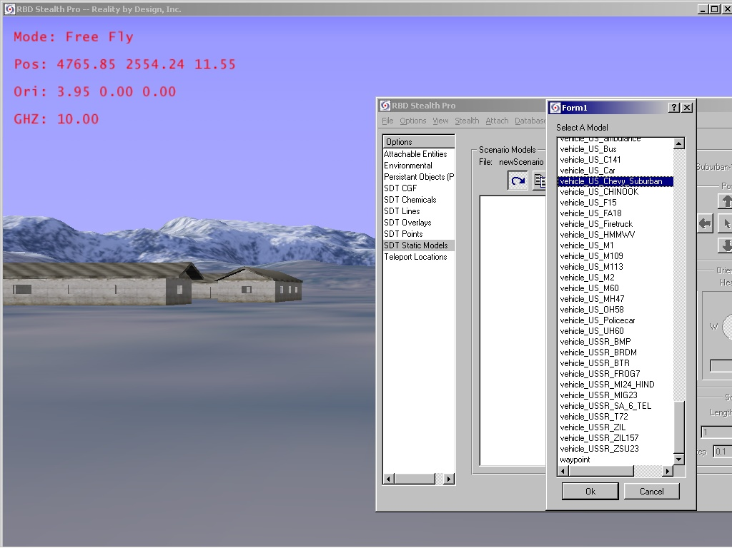

To select a model, the user will click SDT Static Models and then click the arrow to bring up the list of different models available to place.

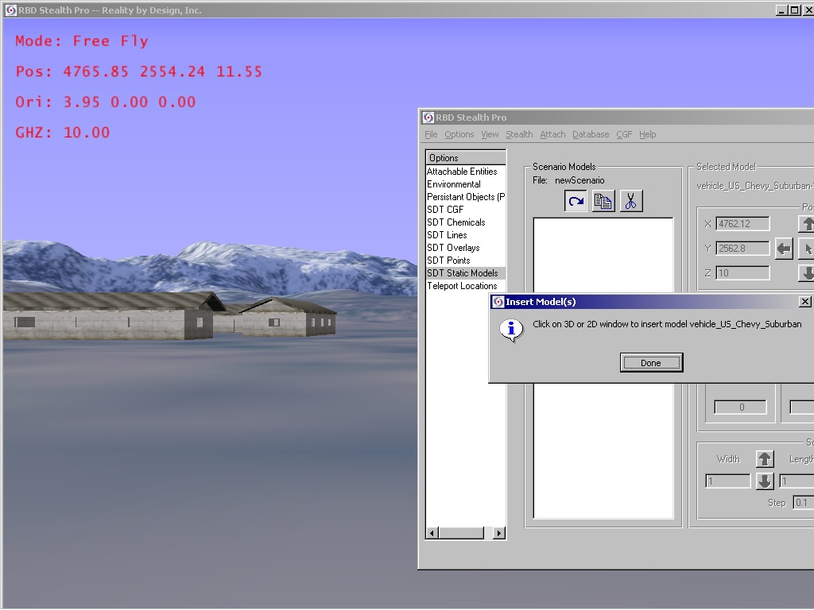

When selection of model is complete, the user can place the object in the virtual world by clicking on the screen with the mouse to place the entity.
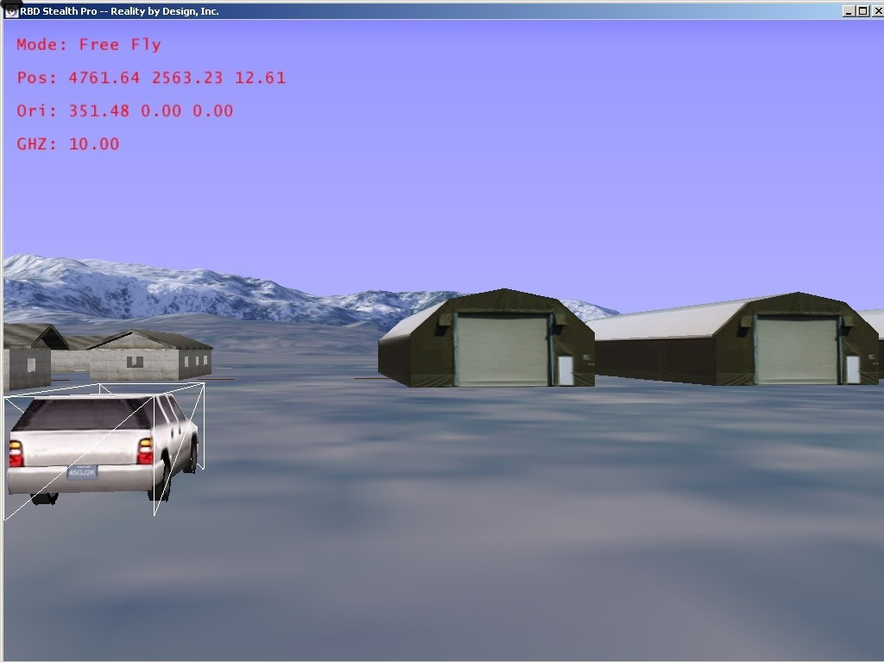

The Model will then appear where the mouse cursor was placed when clicked.
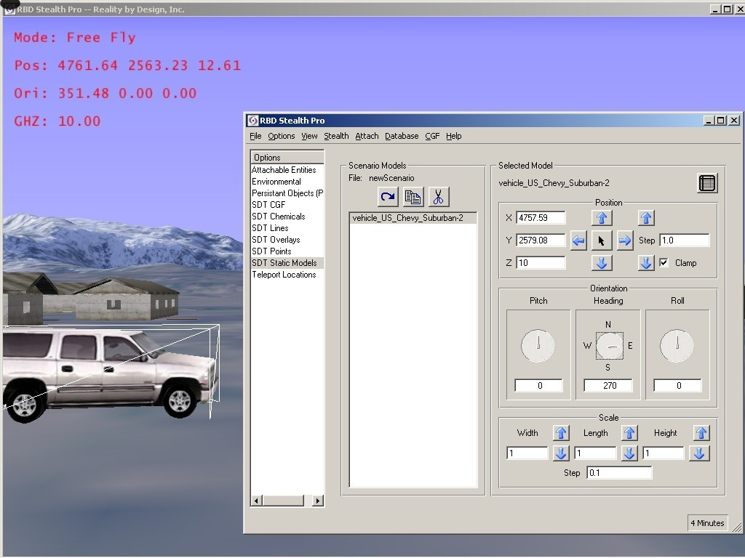

The model placement can then be modified from that position to any another by placing the mouse cursor on the heading compass and hold down the left mouse button and changing the heading.
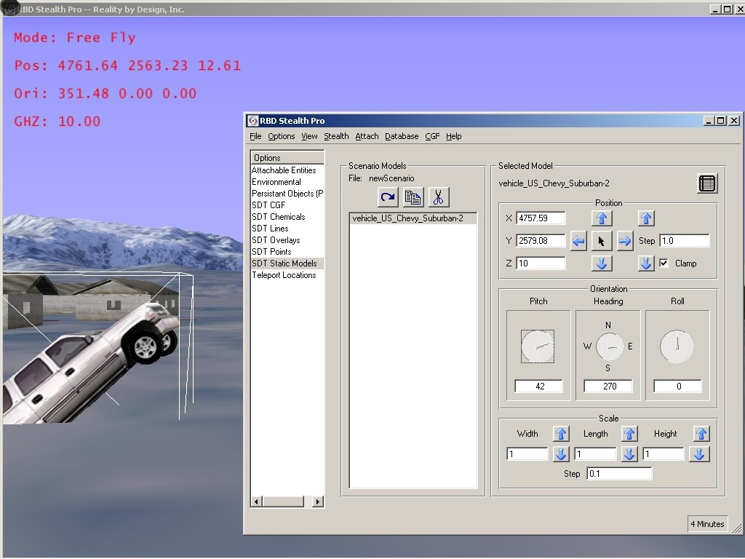

The model can also be reoriented by its pitch; using the same method for changing heading.
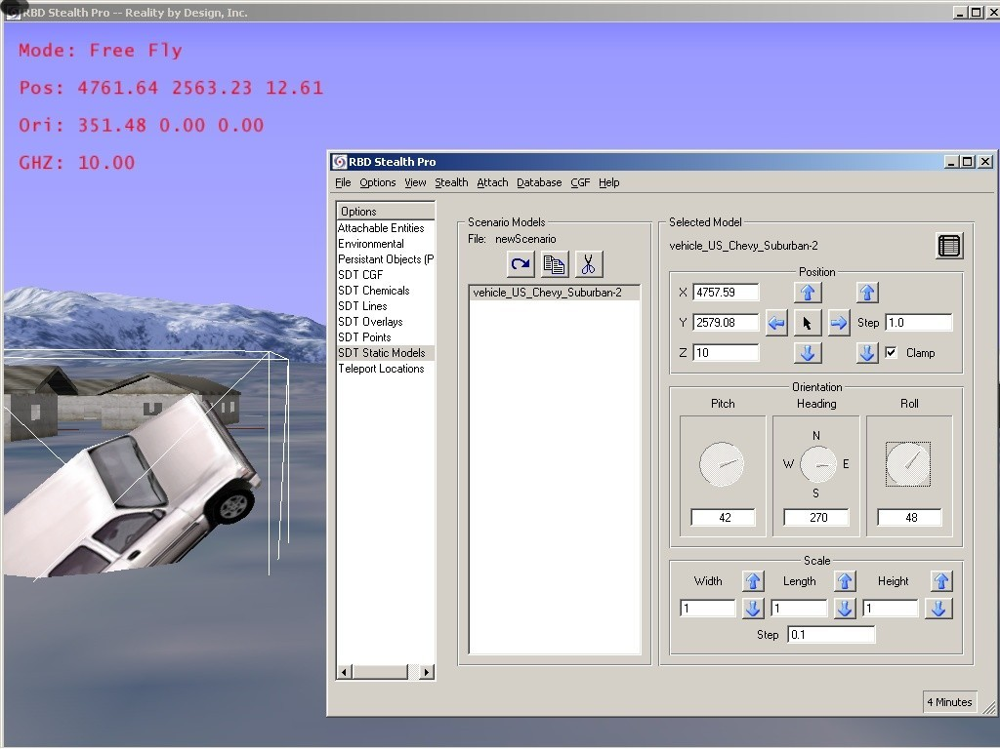

The same can be done for its roll axis.

The SDT can also place human entities in the virtual environment and change their status from alive to dead. The entities are placed in the same manner as placing vehicles, chemicals, munitions and other static models. 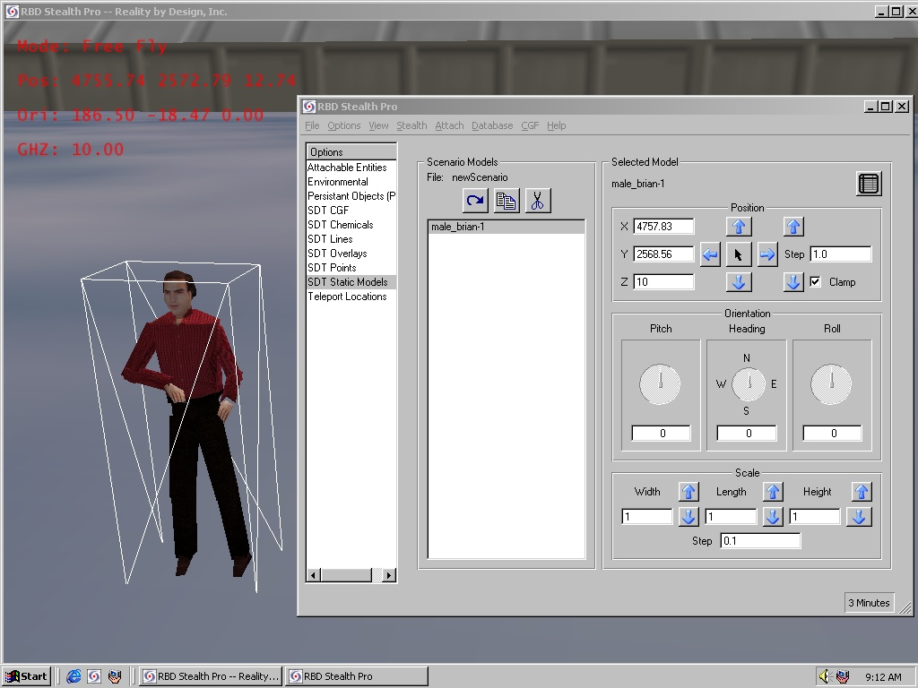

From the static models list, the user can select from a number of different human models to place in the scenario.

Once the model has been placed, you can change his or her status or position from a separate drop down menu on the right hand side of the GUI

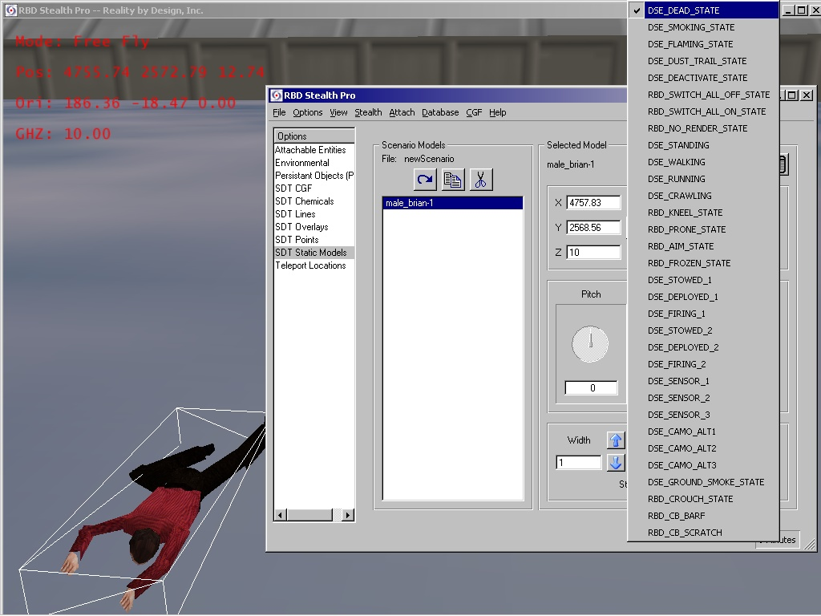

The drop down menu allows the user to select different states such as walking, standing, prone, and dead.
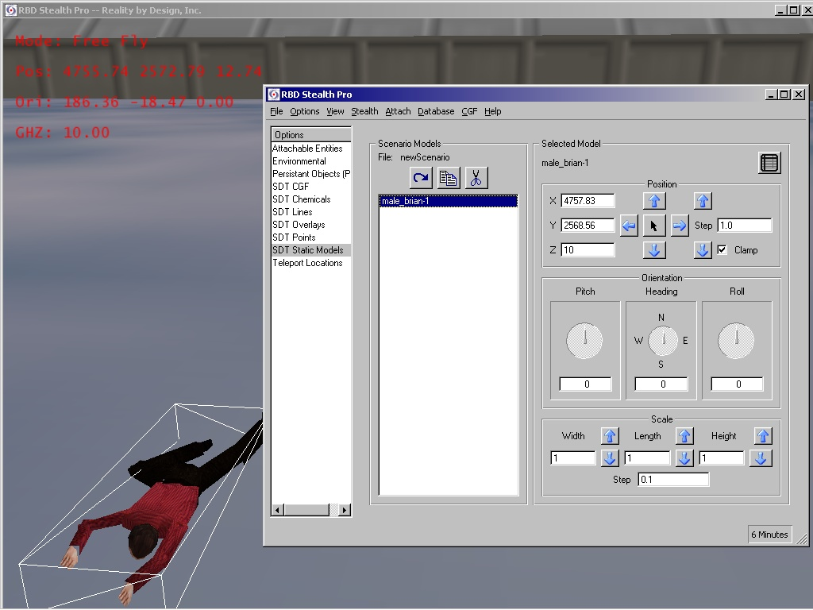

Once the state of the model has been selected , the model can be repositioned using the same methods for changing the pitch, roll, and direction as the other model

Troubleshooting

General Visualization

Symptom | Possible Cause | Solution
Cannot see activity from other simulators | Network cable not connected, or faulty | Connect known good cable from PC’s Network connector.
 | Network settings incorrect | Select the Control Window, then select Options from the File menu. Select DIS, then verify proper Site and Host settings per your Network Administrator. (Restart the System if changes are required).
 |  | Exit SimStorm. Restart SimStorm. Select the Profile to be used, select the Profile menu, then Profile Options. Select the SVS 2 EXTRA, or DIS Tab, and verify Exercise and Port settings per your Network Administrator.
 |  | Exit SimStorm. Use Windows “Find” to determine if a file named “/etc/assoc.def” exists – if so, re-name it to assoc.de_., then re-start SimStorm.
 |  | Exit SimStorm. Check the WINDOWS NETWORK settings in the WINDOWS CONTROL PANEL. (Restart the System if changes are required).
 | Far Clipping Plane is blocking their visibility | Relocate yourself using the Teleport feature, or change the CLIPPING PLANE – FAR value in the DATABASE Tab of Profile Options.
 | Viewing azimuth is wrong | Use the Joystick to rotate throughout a 360 view. Move to look around buildings and other view obstructions.HINT:

 |  | Enable ENTITY OVERLAY in the Visual Tab of Profile Options to determine if any other entities are present.
Displayed view is “incorrect” | View angle is not parallel to terrain base | Use “HAT” control on Joystick to vary view angle.
 | Elevation is above or below the terrain base (i.e. ground level) | Check that “Z” value in Teleport moves is not excessively large, or negative.
 | Special visual settings are active | Check that “Night Vision Goggles” or “Thermal Sights” are selected as desired.
 | Clipping has obscured expected items from view. | Check that the NEAR, and/or FAR CLIPPING PLANE in the Visual Tab of Profile Options is set appropriately
Viewport location incorrect | Invalid Start or Teleport value | Try a different (known valid) Teleport location
Cannot see Human Entities | Human Animator Plug-in not enabled | Exit SimStorm. Restart SimStorm. Select the Profile to be used, select the Profile menu, then Profile Options. Select the Visual Tab and click the checkbox to enable the Animator (e.g. DI Guy).
 | Human Animator Plug-in not properly installed (license) | Contact RBD.

Abnormal Or No Display

Symptom | Possible Cause | Solution
No display | Power to the Monitor is off | Press power switch. Check power cord and AC outlet.
 | No signal to the Monitor | Check the Monitor signal cable.
No Simulation Window | The Window is minimized | Check the Taskbar (normally at the bottom of the screen) to see if an Icon is present – if so, click it to redisplay the Window.
Control Window will not respond | Simulation Window is minimized | Double-click RBD Icon on the Windows Taskbar to restore the Simulation Window, then utilize the Control Window.

Sound

Symptom | Possible Cause | Solution
No sound | Sound is not enabled in the Profile | Create a new Profile with proper Audio settings (audio setting cannot be changed in an existing Profile).
 | The Windows sound level is too low, or is set to “mute” | Click Speaker Icon on Taskbar to check main and WAV volume settings and that Mute is off.
 | The speakers are turned down, off, or are disconnected | Verify that Speakers are connected to proper jack (marked SPKR, not LINE OUT or MIC). Check Speaker Volume Knob (if applicable). Set to maximum, then use Window’s Volume Control for best results.
Improper sound level | Windows volume setting incorrect | Click Speaker Icon on Taskbar to check main and WAV volume settings and that Mute is off.
 | Speaker volume setting incorrect | Check Speaker Volume Knob (if applicable). Set to maximum, then use Window’s Volume Control for best results.

Weapon / Firing

Symptom | Possible Cause | Solution
When firing, your local entity is destroyed | Firing at too close range (variable depending on weapon type) | Move farther away from target.
Cannot fire weapon | Out of ammunition | Reload (Reload may be limited by settings in the Profile). If the allotted ammunition supply is exhausted, the reload button on the Joystick will not function. Select the Control Window, then select RESET AMMO from the SVS menu.
 | Weapon in “Safe” mode | If the weapon-firing mode is set to “Safe”, the trigger will not respond. Use the C- CHECK STATUS button on the Joystick.
Object does not demolish when hit | Some objects on the simulation screen may not be set to allow them to incur damage from being hit | Contact RBD for information on enabling visualization of demolition.
 | Some weapons will have no effect on certain objects (e.g. an M16 will have no effect when firing at a Tank, or the wall of a building) | Select a weapon intended for building demolition.
 | Dynamic Terrain display not enabled | Check the DYNAMIC TERRAIN setting in the Visual Tab of Profile Options
The results (e.g. a hole) of a hit may take several seconds to appear on that object | Normal operation | Reducing the FAR CLIPPING PLANE value in Profile Options may increase rendering speed.

Movement / Joystick Response

Symptom | Possible Cause | Solution
Cannot move | Local entity is up against something that is below the viewport | Use the Hat control to look downward for a low object that may be blocking movement.
 | Joystick disconnected or faulty | Check connections. Replace Joystick.
 | Incongruity in the Terrain Database | Try the UNSTICK control in the Control Window.
 |  | Reload the Terrain Database.
Movement speed seems limited | Normal operation | Rate of movement and mobility are limited to realistic human capabilities for the current posture.
Movement is slower in a kneeling or prone position than when standing | Normal operation | Use the POSTURE buttons on the Joystick to change posture to standing.
Cannot move through a high level opening | Normal operation | It is not possible to “climb” or jump up through a high level opening.
Movement of Local Entity occurs with no input from this Workstation | Another Workstation in the same simulation is using the same Host and Site settings | Coordinate with other Workstations to use unique settings for each station.

Third Person View

Symptom | Possible Cause | Solution
Cannot see the local entity | Human Animation not enabled | Check that DI Guy is enabled in the Visual tab of Profile Options.
 | Viewpoint is a meter behind the depicted local entity, and may be inside a building | Check that the depicted local entity’s back is not very close to another object.
 | Viewing angle results in looking over local entity’s head, or at the ground | Check the viewing angle as set by the HAT on the Joystick.
Weapon firing is not in line with the displayed weapon barrel | Normal. The weapon shown is not to be used for aiming purposes | Ignore weapon image. Firing is straight ahead.
Cannot see Local DI Entity | Human Animator Plug-in not enabled | Exit SimStorm. Restart SimStorm. Select the Profile to be used, select the Profile menu, then Profile Options. Select the Visual tab and click the checkbox to enable the Animator (e.g. DI Guy).
 | Human Animator Plug-in not properly installed (license) | Contact RBD.

Entity Marking

Symptom | Possible Cause | Solution
Entity marking is not as expected | Local Entity Marking content is determined by settings input by the Workstation controlling that entity | Contact operator of Simulation Workstation that created that entity.
 | Only the first 3 characters of the Entity Name can be displayed directly on an animated human participant | Use abbreviated entity marking text strings – only the first 3 characters can be displayed.
Remote Entity markings appear over buildings (even if those entities are outside of the Far Clipping Plane setting) | Display (i.e. enable/disable) of Entity Markings is controlled by local Profile settings. If enabled, that marking will be superimposed over objects (e.g. buildings) in the scene when those objects are positioned between your viewpoint and an Entity that is out of your line of sight (regardless of range) | Turn off ENTITY OVERLAY in the Visual tab of Profile Options to eliminate that display.

Obtaining Assistance

This section explains how to obtain assistance for use of the Reality by Design SVS Desktop System when the information in the previous Problem Solving section did not resolve the problem.

Reality by Design is fully committed to excellent support for its products.

Phone Support | If you obtained your product from an authorized Reality by Design representative, you should initially contact them for support. For headquarters phone support, please contact us at 800-260-4044 during normal business hours in the U.S. Pacific time zone.
FAX | You can FAX your service needs or questions to us at (831) 655-0885.

Returning Products

This section explains how to return the Reality by Design SVS Desktop System for repair or other purposes.

Following this procedure will help assure that your product return is handled efficiently.

In-Warranty Returns
Equipment returned to Reality by Design for warranty repair must be shipped pre-paid. Reality by Design will return equipment under valid warranty pre-paid.

Non-Warranty Returns
Reality by Design requires a confirmed purchase order before performing non-warranty work. To avoid delays, please arrange this prior to returning equipment to Reality by Design.

All Equipment Returns
To return equipment to Reality by Design:

Contact Reality by Design Customer Support to obtain a Return Material Authorization (RMA) number:
- Telephone - 800-260-4044
- Fax: - (831) 655-0885
- E-mail - support@rbd.com
IMPORTANT
To help ensure your equipment is properly tracked, DO NOT return any equipment without an RMA.

Include a letter describing the problem. Your correspondence must include:

- The purchase order number or Reality by Design™ order number from your original invoice.

- The name, telephone, and FAX number (including the area code and extension) of the person at your firm to contact regarding the equipment.

- The address and person to which the equipment is to be returned.

- The address and person to which the repair bill should be sent.

- A description of the problem, and the application conditions.

- An authorization of the work, and a request for the corrections to be performed at Reality by Design™.

Reference all documents and correspondence to the RMA# you are assigned.

Return the equipment and the above report to the address provided by Reality by Design.

NOTE: Return addresses may vary depending on the specific situation.

We recommend that you make careful record of the wiring arrangement prior to disconnecting the Reality by Design SVS System for return. It is also advisable to make a complete record of the Profile settings to aid in replacement of the unit and restoration of previous operations.

Please call our Customer Service Department if you have questions or need more information.

Appendix A

Computer Basics

Computer Terms
This manual uses the following computer terms:
[keyname] Names of keys on the keyboard (like [Enter], [Ctrl], or [Esc]) are enclosed within the [ ] symbols. When simultaneous keystrokes are required, the key names will be separated by a plus sign, for example: the capital letter “T” is [Shift] + [T].
click Depressing and releasing the left button on the mouse.
cursor The point on the monitor where the mouse is pointing or where the next character or action will take place. Cursors can take various shapes including arrows, lines, pointing hands, etc.
double click Quickly depressing and releasing the left button on the mouse twice.
drag Depressing and holding the left mouse button while moving the mouse.
drop Letting go of the left mouse button after dragging the mouse.
folder A computer location in which files are stored. Similar to a folder in a filing cabinet.
keyboard The typewriter-like input device
monitor The TV-like device that displays computer information.
mouse The hand-held device that move the cursor around on the computer screen.
pipe A vertical line between words that represents a series of actions. For example, File | Exit means to click on File and then Exit.
right-click Depressing and releasing the right button on the mouse.
screen The image displayed on the monitor. Often used interchangeably with “window.”
window A part or all of the image on a computer monitor display. Often used interchangeably with “screen.”

Windows® Conventions
Windows uses graphic boxes for the computer operator’s interface. The computer operator may click on areas (called bars and buttons) to control the program. Windows may have one or more “panes” for viewing different types of information.
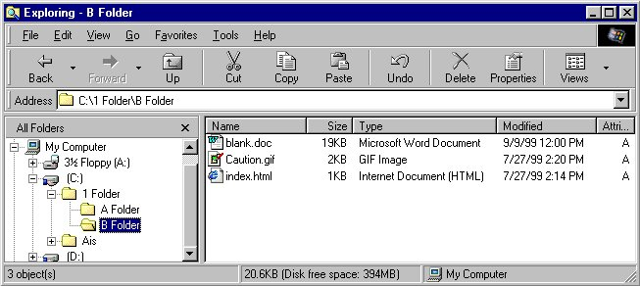
Title Bar
Menu Bar
Tool Bar
System Buttons
Status Bar
Panes
Window Elements
The title bar contains the name of the program running in the window. The system buttons are on the right side of the title bar. These buttons control the window itself as follows:
Minimize | Clicking the minimize button collapses the window into a button on the Windows taskbar which is usually at the bottom of the screen. (The taskbar can be moved to any edge of the screen.)
Maximize  Restore | The resize button can take one of two shapes. Clicking the maximize button enlarges the window to its maximum size. Clicking the restore button shrinks the window to its normal size.
Close | Clicking the close button closes the window, but will not close any associated applications. AIS recommends closing software applications by clicking File | Exit, File | Close, File | Quit, etc.
The menu bar contains words like File and Help. Clicking a word pulls down a menu or box of words from which to choose.
The toolbar contains buttons used to control the functioning of the program.
The status bar displays information about the object the cursor is pointing at.
Windows may also contain other types of controls such as:
Check boxes indicate a list of options from which to choose. Clicking inside the box inserts a check mark and selects the option. A second click removes the checkmark and deselects the option.
Option buttons or radio buttons indicate mutually exclusive options. Clicking inside a button will move the “dot” to the selected option.
Pulldowns are associated with lists of options from which to choose. Clicking the pulldown exposes the list. Clicking the option places the option name in the associated small text window.
Spin or Up/Down buttons are used to increase or decrease a number shown in an associated text box.

Turning the Computer Off
Windows requires a special procedure before shutting off power to the computer.
“Windows” must be “shut down” properly prior to turning power off. Turning off power to the computer before it has been properly “shut down” may prevent a normal system startup and MAY DAMAGE THE SYSTEM.

Here are procedures to shut down the computer in the order of preference:

Method 1: Normal Shutdown
- On the menu bar of the application program window, click File | Exit (or Close or Quit) or the close button in the upper right corner of the screen. The program will shut down. Repeat this step for all programs that appear on the taskbar.
- Move the cursor to the bottom of the screen. The taskbar will appear.
- Click on Start, then Shut Down…, then Shut down. The computer monitor will display a window that reads, “Please wait while your computer shuts down” for a moment, then “It’s now safe to turn off your computer.”
- Turn off the power to the computer.

Method 2: Program Not Responding Shutdown
If a program “freezes up” or a program behaves abnormally, it may be necessary to press [Ctrl] + [Alt] + [Del] all at the same time. Doing so will open the Close Program dialog box.
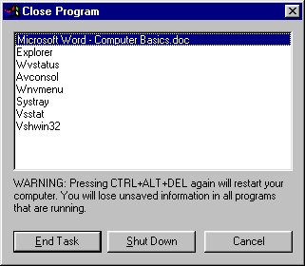
Close Program Dialog Box
If a program is not responding, click it and then click the End Task button. In a few moments another dialog box will appear and ask for confirmation to close the program. Click OK or Yes and wait for Windows to close the program. It may be necessary to wait fifteen minutes for Windows to do so. After Windows closes the program, try to shut down the computer normally.
—OR—
Click Shut Down. It may be necessary to wait fifteen minutes for Windows shut down.

Method 3: Abnormal Shutdown
If the computer “freezes up” and does not respond to any commands, press [Ctrl] + [Alt] + [Del] all at the same time.
If the Close Program dialog box appears, click Shut Down. It may be necessary to wait fifteen minutes for Windows shut down.
—OR—
If the Close Program dialog box does not appear, press [Ctrl] + [Alt] + [Del] again. It may be necessary to wait fifteen minutes for Windows shut down.

Method 4: Emergency Shutdown
If none of the other methods above have worked, turn off power to the computer.
When the computer is restarted, Windows may perform ScanDisk or may start in Safe Mode or both. In either case, refer to the Windows documentation.

Glossary

The following terms are defined as they apply to the end-user SimStorm™ simulation environment:

A/A | Air-to-Air
A/G | Air-to-Ground
AAA | Antiaircraft Artillery
ACR | Advanced Concepts Research domain
ACR/RDA | Advanced Concept Research/Research, Development, & Acquisition
ADST | Advanced Distributed Simulation Technology
AGL | Above Ground Level
AGM | Air-to-Ground Missile
AI | Air Interdiction/Air Intercept
AIC | Air Intercept Control
AIM | Air Intercept Missile
AM | Amplitude Modulation
AO | Area of Operations
API | Application Programmer’s Interface
ARI | Army Research Institute
ARL | Army Research Lab
ARM | Anti-Radiation Missile
ARPA | Advanced Research Projects Agency
ASCM | Anti-Ship Cruise Missile
ASM | Anti-Ship Missile
ATI | Advanced Telecom Incorporated
ATM | Air Tasking Message
ATO | Air Tasking Order
AUSA | Association of the United States Army
AWACS | Airborne Warning and Control System
BAA | Broad Agency Announcement
BFV | Bradley Fighting Vehicle
BLRSI | Battle Lab Reconfigurable Simulator
BLUFOR | Blue Force
BOE | Basis of Estimate
BOS | Battlefield Operating System
BRAA | Bearing, Range, Altitude, Aspect
BVR | Beyond Visual Range
C2 | Command and Control
C4I systems | Command, Control, Communications, Computers and Intelligence systems
CAP | Combat Air Patrol
CATT | Combined Arms Tactical Trainer
CCH/N | Computer Controlled Hostiles/Neutrals
CCTT | Close Combat Tactical Trainer
CGF | Computer Generated Forces
CID | Combat Identification
DBBL | Dismounted Battlespace Battle Lab
DI | Dismounted Infantry
DIS | Distributed Interactive Simulation
DMSO | Defense Modeling and Simulation Office
DoD | Department of Defense
DOMS | DoD Office of Military Support
DTO | Defense Technology Objective
DWN | Dismounted Warrior Network
DWN-ERT | Enhancements for Restrictive Terrain
FLIR | Forward Looking Infrared
FOM | Federation Object Model
FOV | Field of View
GUI | Graphical User Interface
GREYFOR | Neutrals, or unknown (friendly or enemy)
HCI | Human-Computer Interface
HITL | Human in the Loop
HLA | High-Level Architecture
HMD | Head (or Helmet) Mounted Display
HPR | Heading, Pitch, and Roll
HUD | Head’s up Display
IC SAF | Individual Combatant SAF (Semi-Automated Forces)
IC | Individual Combatant
ID | Identification
IDA | Institute for Defense Analyses
IFF | Identification, Friend or Foe
IHAS | Integrated Helmet Assembly Subsystem
IPR | In-Progress Review
IPT | Integrated Product Team
IR | Infrared
IST | Institute for Simulation and Training
LatLong | Latitude, Longitude
LOS | Line of Sight
LW | Land Warrior program
LWTB | Land Warrior Test Bed
MC SAF | Marine Corps SAF (Semi-Automated Forces)
MCMSMO | Marine Corps Modeling and Simulation Office
MOBA | Military Operations in Built-up Areas
ModSAF | Modular Semi-autonomous Forces
MOUT ACTD | Military Operations in Urban Terrain Advanced Concept Technology Demonstration
MOUT | Military Operations in Urban Terrain
MSL | Mean Sea Level
NAWC-TSD | Naval Air Warfare Center - Training System Division
NBC | Nuclear, Biological or Chemical
NPS | Naval Postgraduate School
NRaD | Naval Research and Development Center
NVG | Night Vision Goggles
ODT | Omni-Directional Treadmill
OICW | Objective Individual Combatant Weapon
OOTW | Operations Other Than War
OPFOR | Opposing Forces
OS | Operating System
OSCW | Objective Crew Served Weapon
OSF | Operational Support Facility
PC | Personal Computer
PD | Program Director
PE | Project Engineer
PM-Soldier | Project Manager – Soldier
RBD™ | Reality by Design, Inc.
RDA | Research, Development and Acquisition domain
RTI | Run-time Infrastructure
SAF | Semi-Automated Forces
SAM | Surface-to-Air Missile
SBIR | Small Business Innovation Research program
SME | Subject Matter Experts
SOM | Simulation Object Model
SSCOM | U.S. Army Soldier Systems Command
STO | Science Technology Objective
STOW | Synthetic Theater of War
STRICOM | Simulation, Training and Instrumentation Command
SUO | Small Unit Operations program
TEMO | Training Exercises and Military Operations domain
TIM | Technology Interchange Meeting
TOD | Time of Day
TRAC | TRADOC Analysis Center
TRAC-WSMR | TRADOC Analysis Center, White Sands Missile Range
TRADOC | U.S. Army Training and Doctrine Command
UAV | Unmanned Aerial Vehicle
USAIC | United States Army Infantry Command/Center
USMC | United States Marine Corps
UTM | Universal Transverse Mercator – projected coordinate system
VERTS | Virtual Emergency Response Training System
VIC | Virtual Individual Combatant
VSD | Virtual Space Devices
WGS ‘84 | World Geodetic System 1984
WISE | Walk-In Synthetic Environment
WMD | Weapons of Mass Destruction
WMD CSD | WMD Civilian Support Detachment
WMD CST | WMD Civilian Support Team
X,Y,Z | Position coordinates (X-horizontal, Y-vertical, Z-elevation)

